Project Design Phase-II
Data Flow Diagram & User Stories

Date | 31 January 2025
Team ID | LTVIP2026TMIDS71321
Project Name | Dog Breed Identification using Transfer Learning
Maximum Marks | 4 Marks

Data Flow Diagrams:
The Data Flow Diagram (DFD) for the Dog Breed Identification using Transfer Learning project illustrates how data moves through the system from input to output. The process begins when the user uploads a dog image through the web interface. The input image is then sent to the preprocessing module, where it is resized, normalized, and prepared for analysis. After preprocessing, the image is passed to the trained transfer learning model, which has been developed using a pre-trained convolutional neural network. The model analyzes important features such as shape, fur pattern, and facial structure to identify the dog breed. Once the prediction is completed, the system generates the breed name along with a confidence score. The results are then sent to the output module and displayed on the web application interface for the user to view. The system may also temporarily store the uploaded image and prediction results for processing purposes. This Data Flow Diagram helps in understanding how the input data is transformed step by step into meaningful output. It clearly shows the interaction between the user, the processing modules, the machine learning model, and the final output, making the system easier to understand and implement.
.

Example: Dog Breed Identification using Transfer Learning

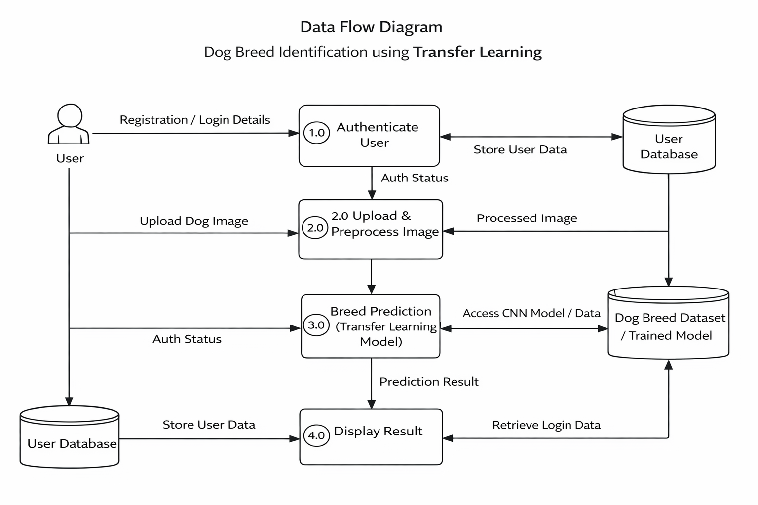

User Stories
Use the below template to list all the user stories for the product.
User Type | Functional Requirement (Epic) | User Story Number | User Story / Task | Acceptance criteria | Priority | Release
Customer (Mobile user) | Registration | USN-1 | As a user, I can register for the application by entering my email, password, and confirming my password. | User can access dashboard after successful registration. | High | Sprint-1
 |  | USN-2 | As a user, I will receive confirmation email once I have registered for the application | User clicks confirmation link and account gets activated. | High | Sprint-1
 |  | USN-3 | As a user, I can register for the application through Facebook | User can register & access dashboard via Gmail. | Medium | Sprint-1
 | Login | USN-4 | As a user, I can log in using email & password. | User successfully logs in and views dashboard. | High | Sprint-1
 |  | USN-5 | As a user, I can log into the application by entering email & password | Password reset link is sent and user can set new password. | Medium | Sprint-2
 | Image Upload | USN-6 | As a user, I can upload a dog image from gallery or camera. | Image uploads successfully and preview is shown. | High | Sprint-1
 | Breed Prediction | USN-7 | As a user, I can click “Predict” to identify the dog breed. | System displays predicted breed with confidence score. | High | Sprint-1
 | Result Display | USN-8 | As a user, I can view breed details (traits, care info). | Breed information page loads correctly | High | Sprint-1
 | History | USN-9 | As a user, I can view my previous predictions. | Prediction history is saved and displayed. | Medium | Sprint-2
 | Share Feature | USN-10 | As a user, I can share prediction results. | Share option works via social media or link. | Low | Sprint-3
Customer (Web user) | Registration & Login | USN-11 | As a web user, I can register and login. | User can access dashboard through web browser. | High | Sprint-1
 |  | USN-12 | As a web user, I can upload dog images. | Image is successfully processed and preview shown. | High | Sprint-1
 |  | USN-13 | As a web user, I receive breed prediction results. | Breed name & confidence score displayed. | High | Sprint-1
Administrator | Model Management | USN-14 | As an admin, I can upload updated trained models. | New model replaces old model without system failure. | High | Sprint-2
 | Dataset Management | USN-15 | As an admin, I can manage dog breed dataset. | Dataset updates reflect in model training. | Medium | Sprint-2
 | User Management | USN-16 | As an admin, I can view and manage users. | Admin can activate/deactivate user accounts. | High | Sprint-2
 |  | USN-17 | As an admin, I can monitor system performance. | Dashboard shows usage statistics & logs. | Medium | Sprint-3
  Monitoring
Customer Care Executive | Support |  | As a support executive, I can view user issues. | Support dashboard displays complaints & queries. | Medium | Sprint-3
 | Feedback |  | As a support executive, I can record user feedback. | Feedback is saved and visible to admin. | Low | Sprint-3

